# *Lab 9 – Input Design Critique*

Date assigned: Friday, October 28, 2016

Date due: **Friday, October 28, 2016, 12:00 p.m.**

**Learning Objectives**

Upon successful completion of this assignment, the student will be able to:

* Critique the input design of web forms
* Work on assignment 3b

To do:

**Record all your answers in bold in a copy of this document named YourUserName_E11_L9_Input_Critique.docx, e.g. JSmith_E11_L9_Input_Critique.docx, and saved in the Labs folder in the 420-E11 folder in your H drive. Record your name below.**

**To submit**

When you have completed the lab exercise, copy the following document to the Moodle page for this course:

* YourUserName_E11_L9_Input_Critique.docx

**Part A: Input Design**

1. For each input screen, critique the input design. Comment on alignment of labels, placement/design of actions, grouping, and use of help. **(5 marks each – 20 marks total)**
   1. Amazon.ca registration

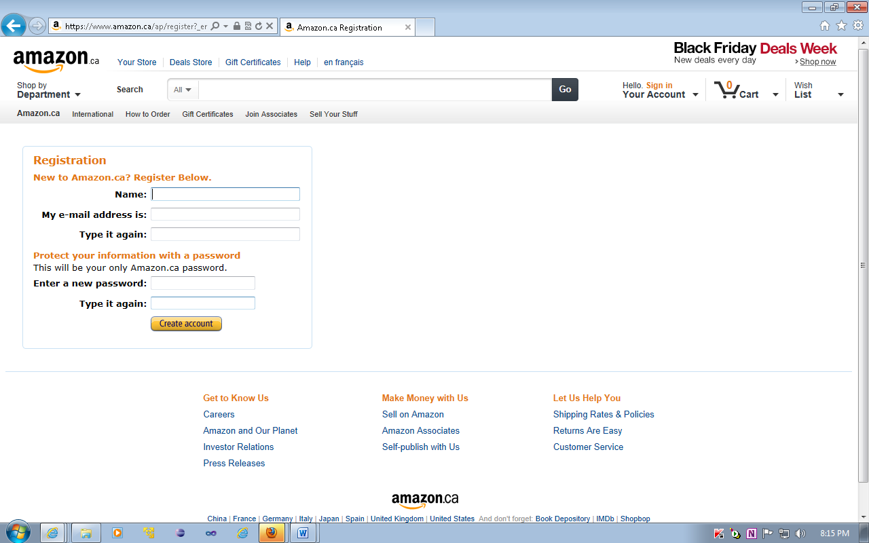

This form is written well. The fields are all evenly sized with relevant information together. The whole form has a common look and feel with the rest of the website. The only complaint I have is that because of the fact that they’re using inline labels and fields, the field doesn’t go down very far, so you have the whole footer intruding into the form. I would use labels above the input fields because it’s mostly common information, so it’s very easy and quick to fill out. The only information that might not be common is the password, but most people have the same password for everything.

* 1. Chapters.ca registration

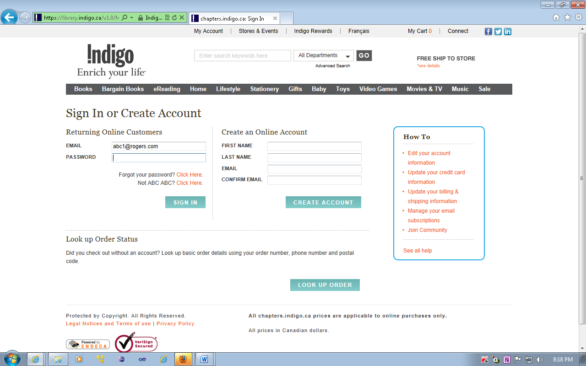

This form is okay, I don’t like the fact that they have the application form and the sign in form on the same page, usually they’re not grouped together like this. I would make the primary page for the form a sign up page, with a button at the bottom saying that can redirect them to a sign in form. Having them both on the same page just looks weird since you have two different visible forms, which could be confusing to some people. Also, the labels are left aligned, which on a form consisting of information most people know very well, that seems a little off. I would right align the labels to the input fields, or drop the input fields down to be below the labels.

* 1. Apple

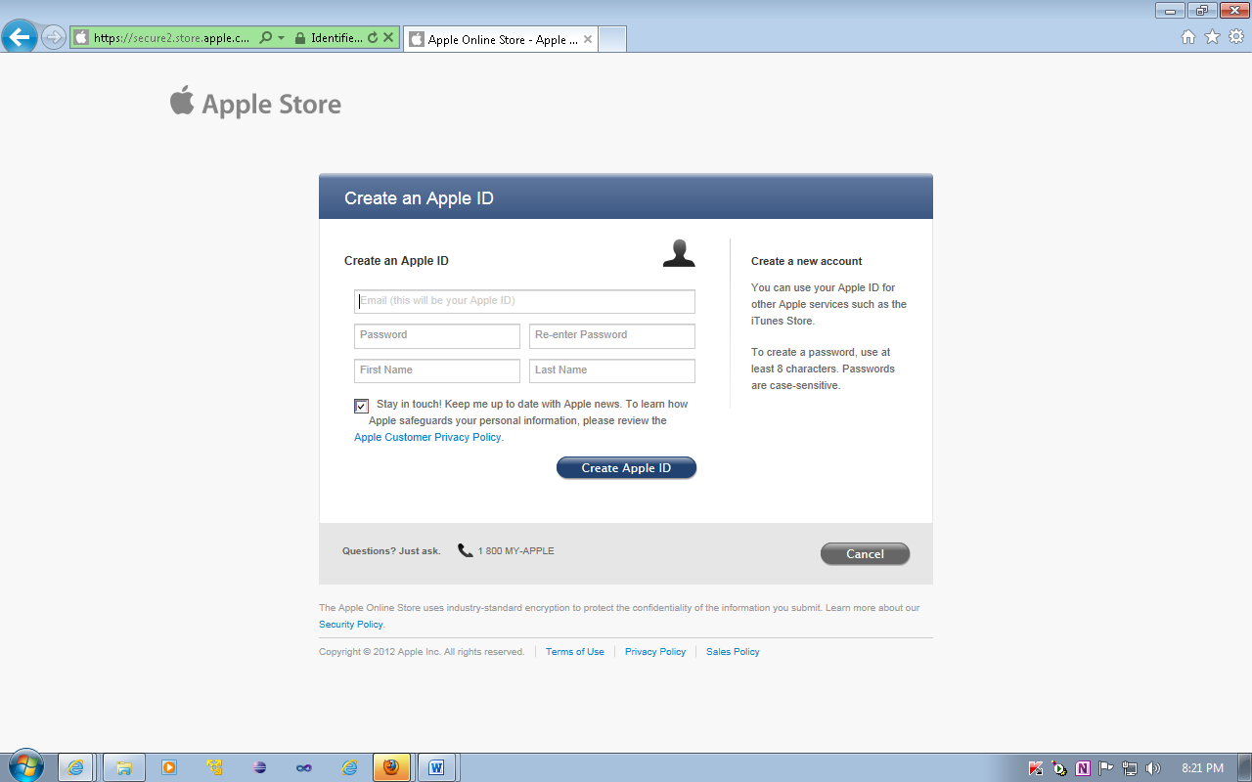

This form is very bizarre… The form looks weird as is, because the whole thing only takes up like, 40% of the view port and there’s a bunch of awkward white space all around the form. The form is also stacked kind of stupidly, why is there information stacked both on top and beside other inputs? I would make the whole form vertical and enter labels. I don’t like the idea of having just placeholders to direct the user, especially since I’ve seen some older people get confused when they fill out a form with placeholders and then watch them disappear. I would also keep the checkbox for an email subscription automatically unchecked, since most people hate getting constant emails from people.

* 1. Student Visa card application (split across two screen shots)

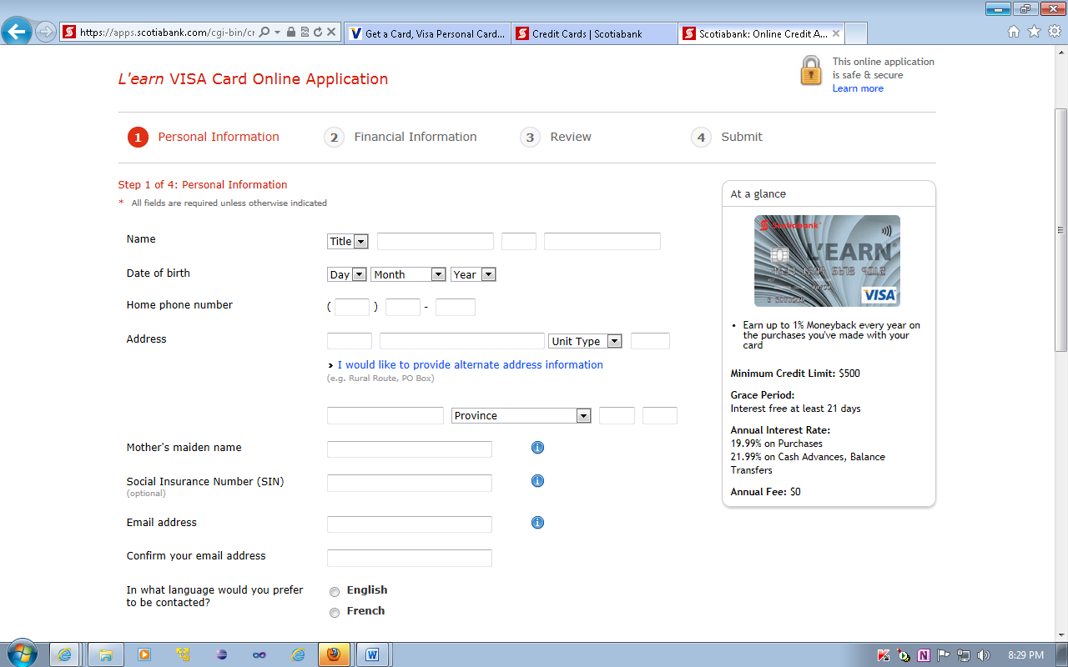

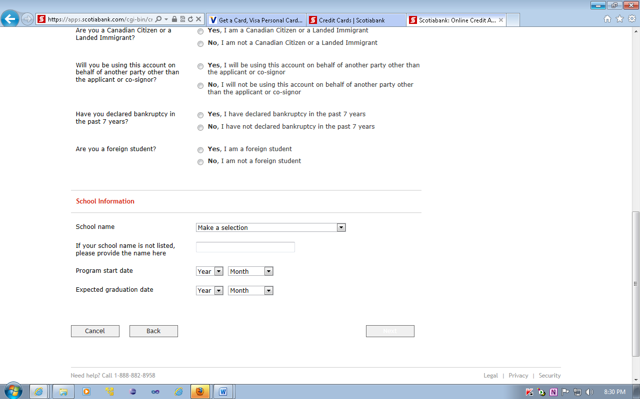

I have mixed feelings about this form. The two portions of the address fields are broken up by the option to add an additional address, which takes away from the flow of the form. I actually agree with the left alignment of the labels on this form. Because of the fact that there’s the questions regarding some security information, stuff that people might actually think about, those inputs should be left aligned. To maintain a common look and feel, keeping all the labels right aligned is probably the right choice. Also, I don’t think if it’s because the next button is currently in focus, or what it is, but having white text inside the next button is never a good idea.